**COVID-19 PREDICTION BY CHEST X-RAYS**

**USING DEEP LEARNING**

**INTRODUCTION**

**Project Overview**

**The "Covid-19 Detection using Deep Learning with Chest X-rays" project aims to harness the power of deep learning algorithms to facilitate early and accurate diagnosis of Covid-19 by analyzing chest X-ray images. The project addresses the critical need for efficient and rapid screening of potential Covid-19 cases, providing a valuable tool.**

**Purpose**

**The purpose of this project is to develop a robust and accurate model for early detection of COVID-19 through analysis of chest X-rays.**

**LITERATURE REVIEW**

**Existing Problems**

**Current methodologies for Covid-19 detection vary in accuracy and efficiency. Some challenges include:**

***Limited Dataset Availability*: Many studies face challenges due to the scarcity of diverse and well-annotated datasets for training deep learning models.**

***Interpretability of Models*: Understanding and interpreting the decisions made by deep learning models in the medical domain, especially in the context of chest X-ray analysis, is a critical concern.**

***Transferability and Generalization*: Ensuring the model's ability to generalize across different populations, demographics, and imaging equipment is crucial for real-world applicability.**

**References**

**"Deep Learning-based Detection for COVID-19 from Chest X-ray Images"**

**Authors: Wang et al., Year: 2020**

**This seminal work explores the application of deep learning techniques for Covid-19 detection using chest X-ray images. The study introduces a convolutional neural network (CNN) architecture and discusses its performance in terms of sensitivity and specificity.**

**"COVID-Net: A Tailored Deep Convolutional Neural Network Design for Detection of COVID-19 Cases from Chest X-ray Images"**

**Authors: Wang et al., Year: 2020**

**This research introduces COVID-Net, a specialized deep learning model for Covid-19 detection. The study focuses on optimizing model architecture for accuracy and generalization across different datasets.**

**"Transfer Learning with Convolutional Neural Networks for COVID-19 Detection using Chest X-rays"**

**Authors: Narin et al., Year: 2020**

**The paper investigates the effectiveness of transfer learning in training deep neural networks for Covid-19 detection. It assesses the model's ability to adapt to limited datasets and varying imaging conditions.**

**"Explainable Deep Learning Models in Medical Image Analysis"**

**Authors: Mahmud et al., Year: 2021**

**Exploring the interpretability of deep learning models, this review discusses methods to make predictions more understandable for medical professionals, an important aspect in the deployment of such systems in clinical settings.**

**Problem Statement Definition**

**Building upon the insights from the literature survey, the specific problems targeted by this project include improving the interpretability of deep learning models, enhancing generalization across diverse datasets, and addressing challenges related to the scarcity of annotated Covid-19 chest X-ray images. The project aims to contribute solutions to these issues through the development of an advanced and interpretable deep learning model for accurate Covid-19 detection from chest X-rays.**

**IDEATION PHASE**

**Project Empathy Map Link :** [**LINK**](https://app.mural.co/t/vitvellore5506/m/vitvellore5506/1699277758647/fa3b2f730fe382faba9dc52f3db5790386bfe3bd?sender=u1937b8f0860246c252ab0367)

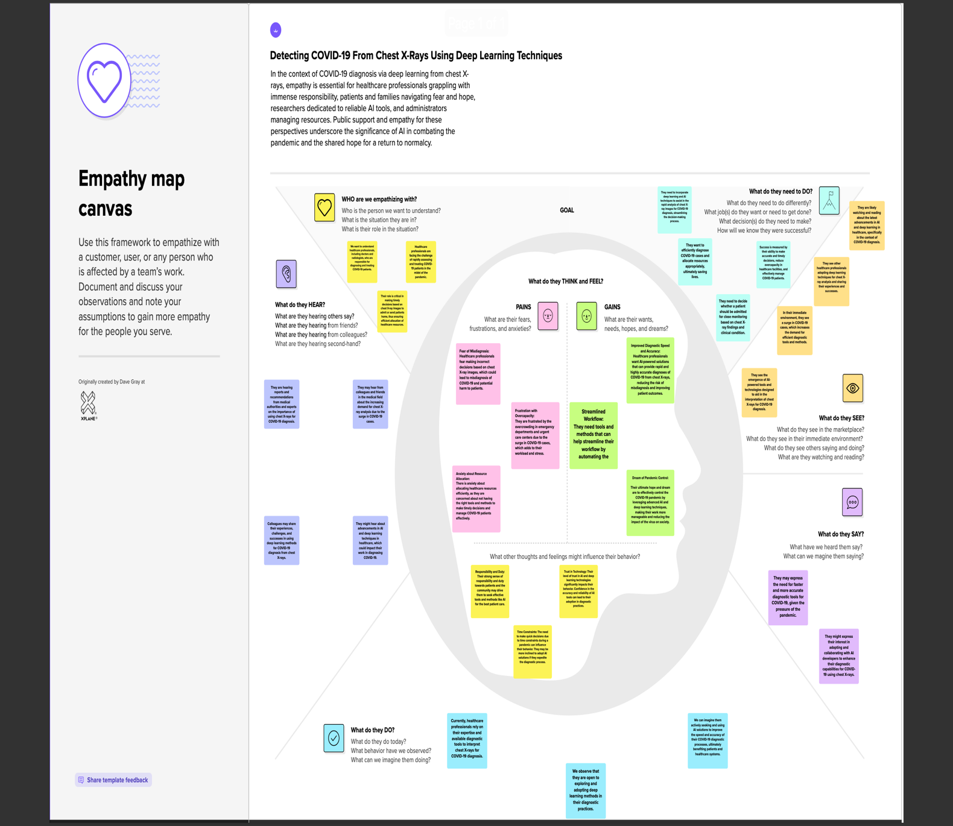

**Brainstorm Link :** [**LINK**](https://app.mural.co/t/vitvellore5506/m/vitvellore5506/1699466231858/8dce10adcc393cd780f7be61841e842ebda4a5a3?sender=u1937b8f0860246c252ab0367)

**Step-1: Team Gathering, Collaboration and Select the Problem Statement**

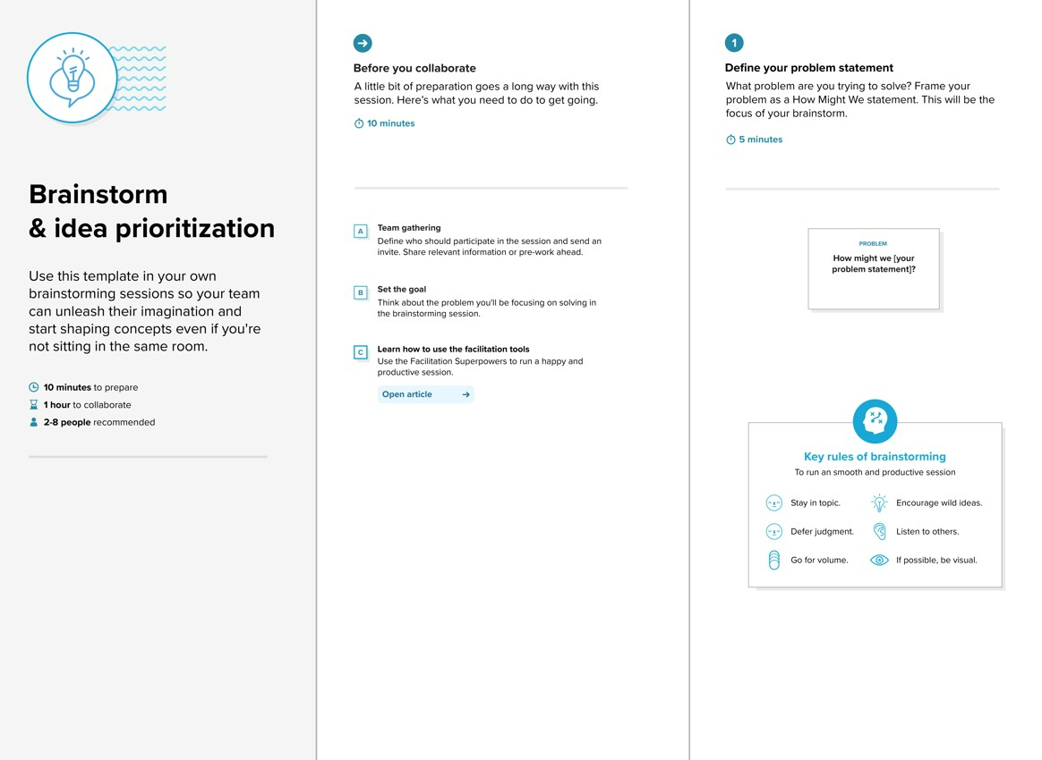

**Step-2: Brainstorm, Idea Listing and Grouping**

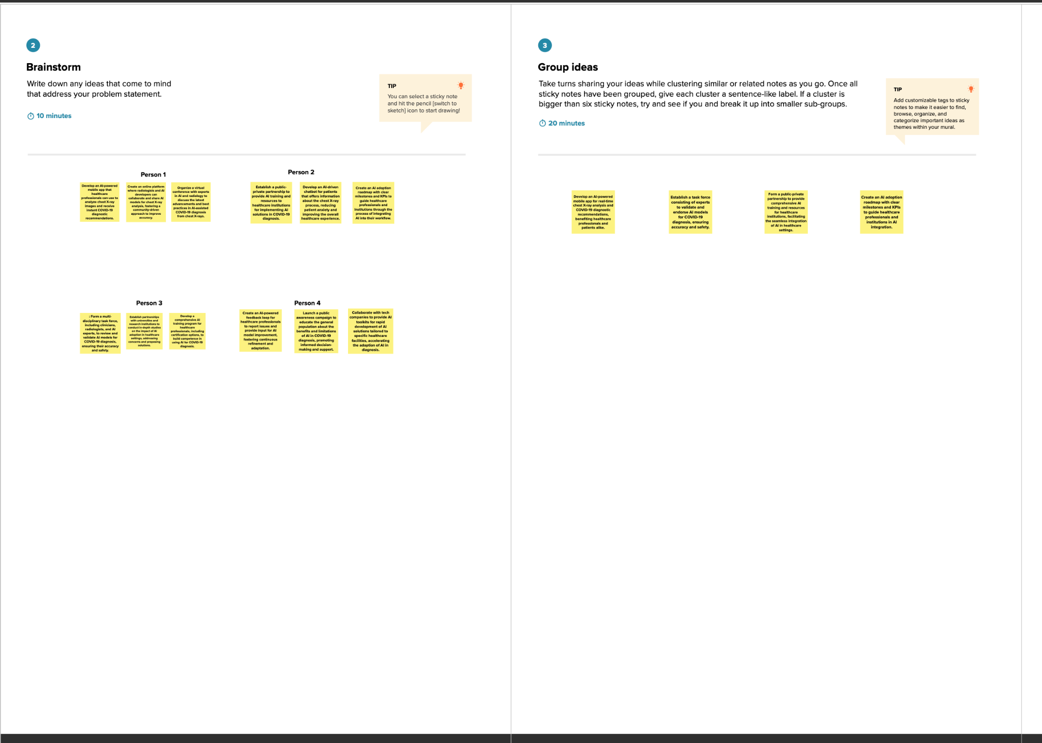

**Step-3: Idea Prioritization**

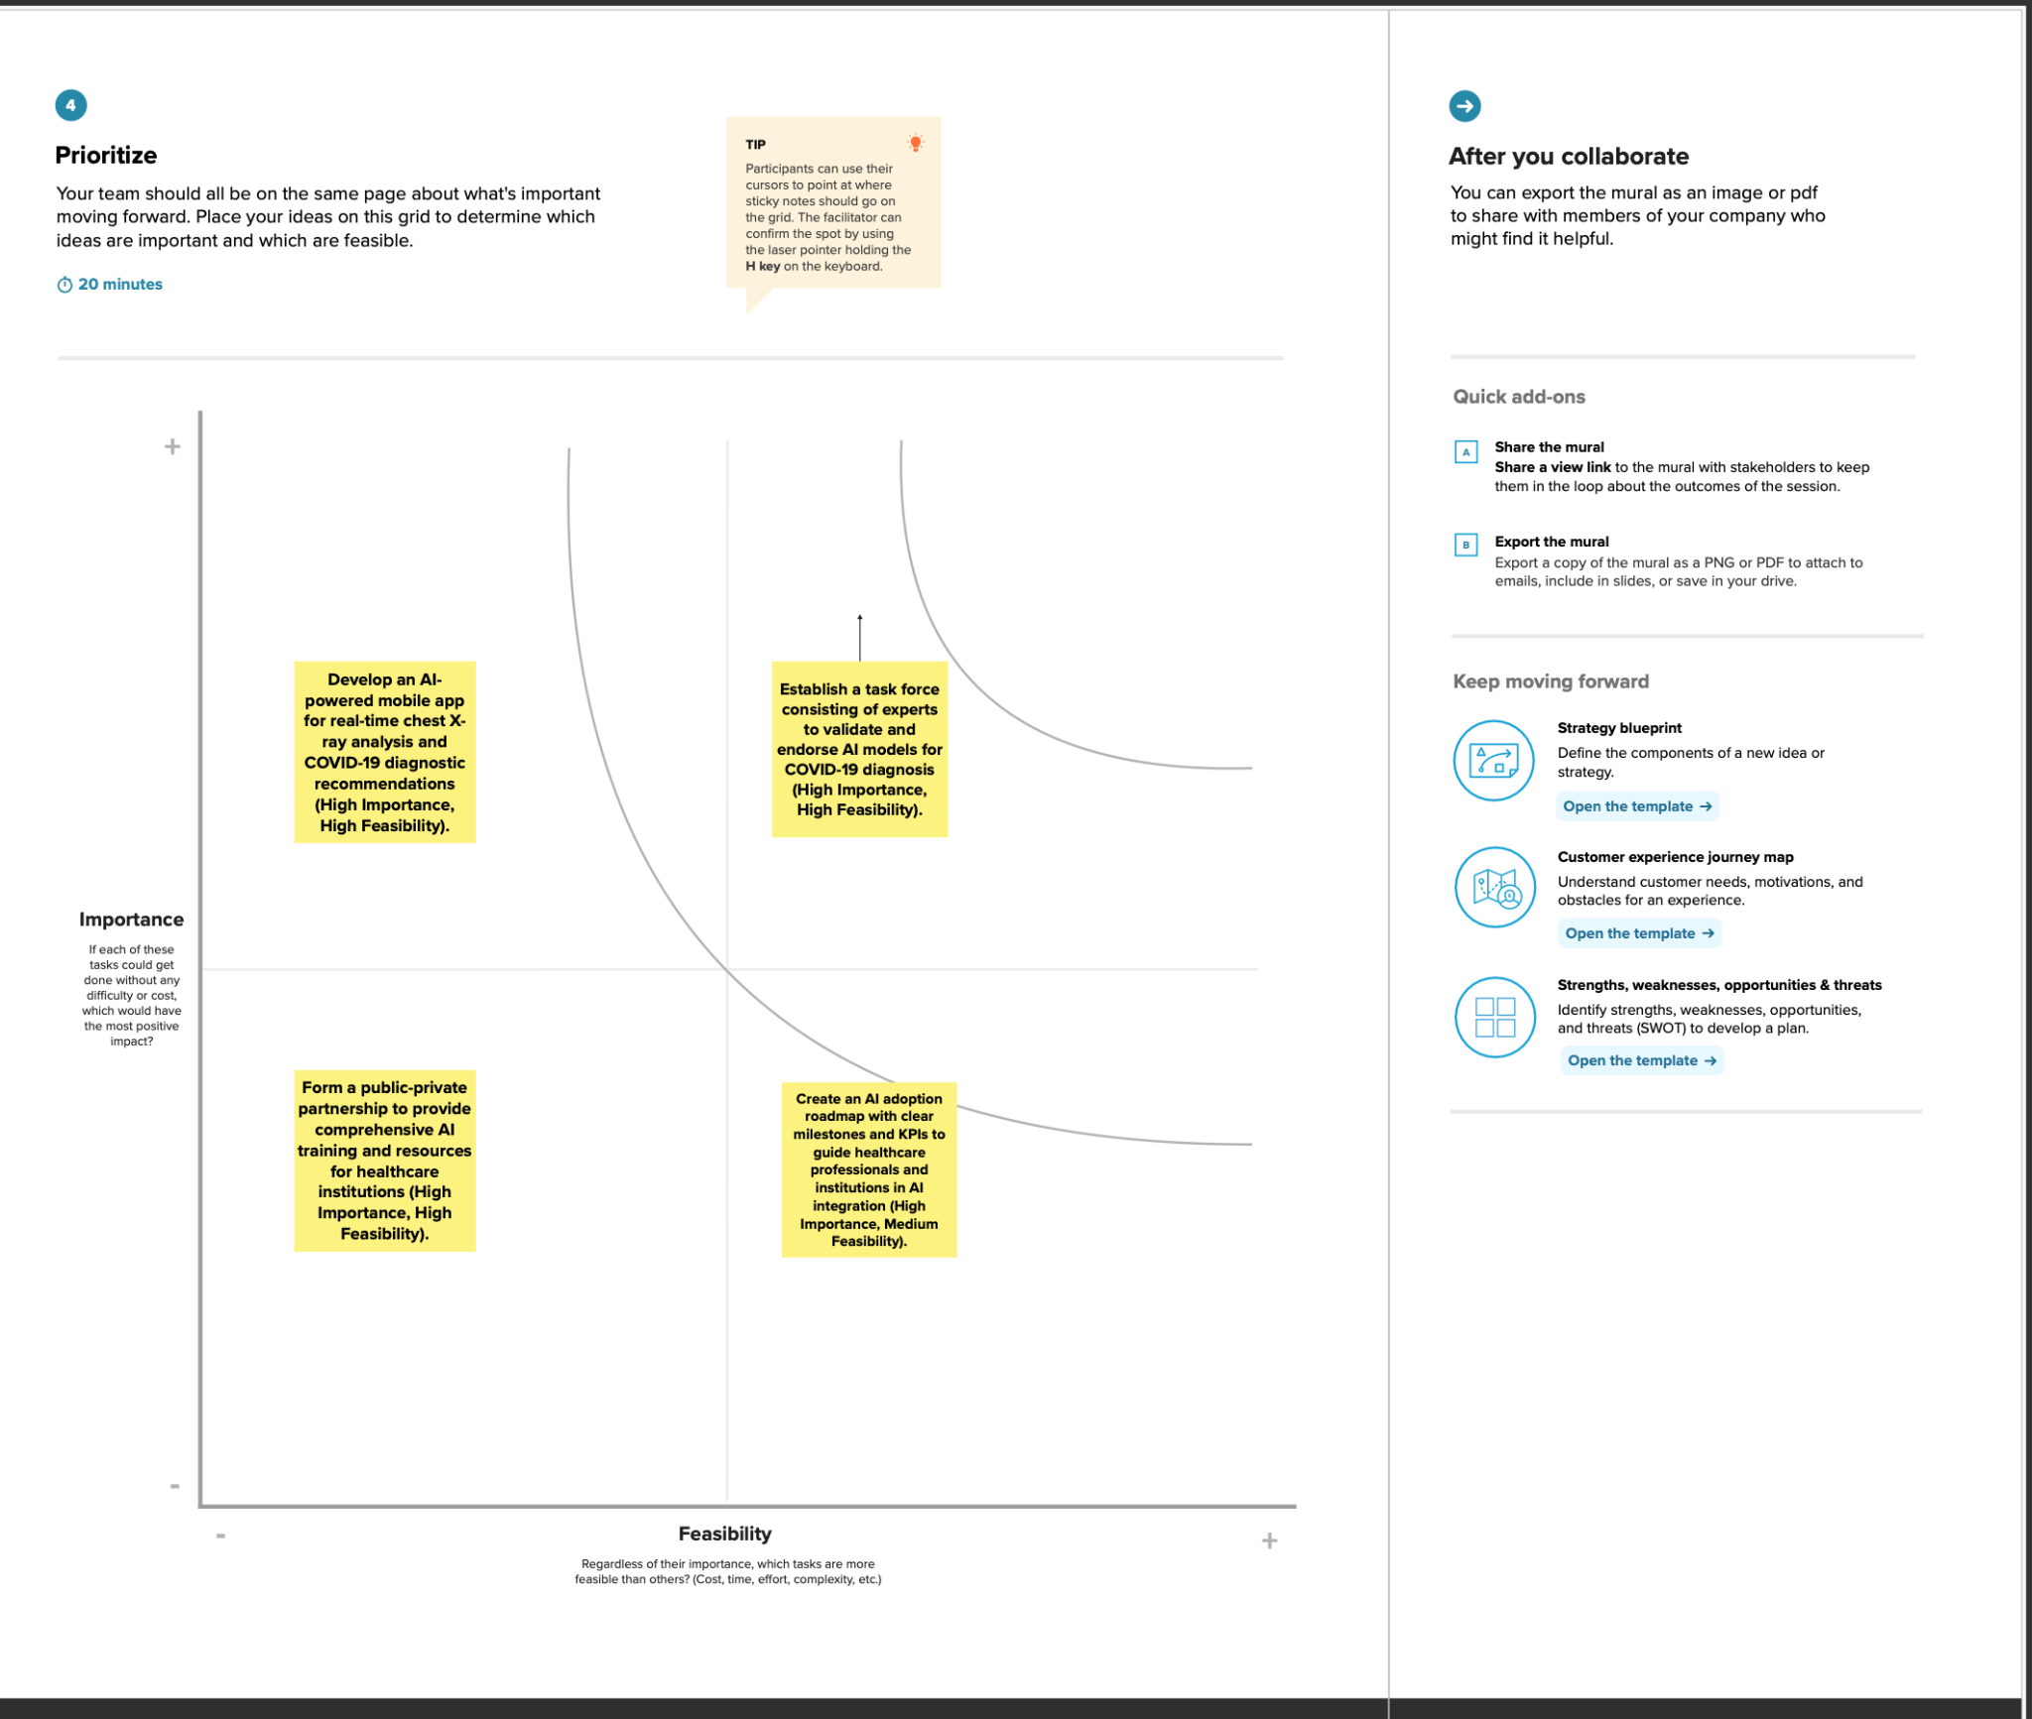

**PROJECT DESIGN PHASE**

**PROPOSED SOLUTION**

**Proposed Solution:**

| **S.No.** | **Parameter** | **Description** |
| --- | --- | --- |
| 1. | Problem Statement (Problem to be solved) | **To develop a robust and accurate model for early detection of COVID-19 through analysis of chest X-rays.** |
| 2. | Idea / Solution description | **The "Covid-19 Detection using Deep Learning with Chest X-rays" project aims to harness the power of deep learning algorithms to facilitate early and accurate diagnosis of Covid-19 by analyzing chest X-ray images. The project addresses the critical need for efficient and rapid screening of potential Covid-19 cases, providing a valuable tool**. |
| 3. | Novelty / Uniqueness | **Our solution stands out due to its use of cutting-edge machine learning techniques tailored for COVID_19 monitoring, ensuring precise and timely predictions.** |
| 4. | Social Impact / Customer Satisfaction | **The solution contributes to faster and more accurate prediction of covid 19 using chest x-rays and not relying on other tests.** |
| 5. | Business Model (Revenue Model) | **Implement a subscription-based model for healthcare providers, offering premium features and personalized analytics. Additionally, collaborate with medical institutions for enterprise solutions.** |
| 6. | Scalability of the Solution | **The solution is designed to be scalable, accommodating a growing number of users and expanding to different healthcare settings. Cloud-based infrastructure ensures flexibility and scalability.** |

**Solution Architecture:**

* **Best Tech Solution:**
  + The "Covid-19 Detection using Deep Learning with Chest X-rays" project aims to harness the power of deep learning algorithms to facilitate early and accurate diagnosis of Covid-19 by analyzing chest X-ray images
* **Behavior and Aspects:**
  + The software behavior is dynamic, adapting to changing data patterns. Aspects include data preprocessing, using best image preprocessing algorithms like RESNET-50, and Transfer learning..
* **Development Phases:**
  + Our application undergoes iterative development phases:
    - Data Preprocessing: Cleaning and preparing data for analysis.
    - Model Training: Using RESNET-50.
    - Evaluation: Assessing model accuracy and fine-tuning.
    - Integration: Seamlessly integrating into existing healthcare systems.
* **Solution Requirements:**
  + Key requirements include:
    - Data Quality: High-quality fetal health data.
    - Computational Resources: Adequate resources for model training.
    - Integration: Compatibility with existing healthcare infrastructure.

**Solution Architecture Diagram:**

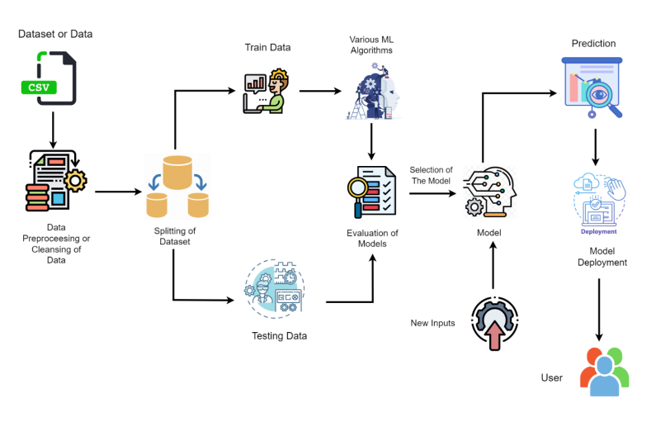

**DATAFLOW AND USERSTORIES:**

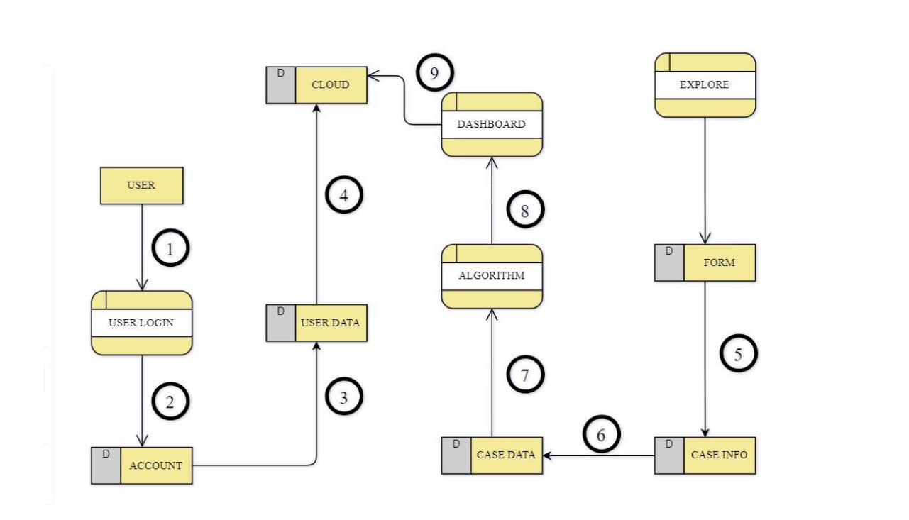

1. Users successfully complete the registration process.

2. Within the Web App's Explore section, users are prompted to input specific characteristics.

3. The provided Case Info undergoes a seamless transformation into formatted Case Data.

4. The transformed Case Data serves as input for the FetalAI algorithm.

5. The algorithm processes the data, predicts the score, and presents the results on a dynamic dashboard.

**User Stories**

Use the below template to list all the user stories for the product.

| **User Type** | **Functional**  **Requirement**  **(Epic)** | **User Story Number** | **User Story / Task** | **Acceptance criteria** | **Priority** | **Release** |
| --- | --- | --- | --- | --- | --- | --- |
| Customer | Registration | USN-1 | As web user, I can register for the application by entering my email, password, and confirming my password. | Successfully entering email, password, and confirming password leads to account creation. | High | Sprint-1 |
|  |  | USN-2 | As user, I can register for the application through smartbridge internz platform. | Successful registration and access to dashboard using smartbridge internz credentials. | Low | Sprint-2 |
|  |  | USN-4 | As a user, I can register for the application through Gmail | Successful registration and access to the FetalAI dashboard through Gmail. | Medium | Sprint-1 |
|  | Login | USN-5 | As a mobile user, I can log into the FetalAI application by entering my email and password. | Successfully entering a valid email and password leads to login. | High | Sprint-1 |
|  | Best Algorithm Finding | USN-7 | Trying out all the available algorithms in order to find which one gives the best accuracy rate | Ability to filter and sort predictions based on parameters such as gestational age, health risk levels, and other relevant factors. | High | Sprint-1 |
|  | Finding correlations | USN-8 | We have a huge number of 21 parameters which can be hectic to handle, hence we shall find correlated columns and eliminate them. | * Access a user-friendly dashboard offering comprehensive insights into health predictions for selected pregnancies. Explore predicted health parameters, receive recommendations, and view relevant data visualizations. Utilize convenient filters and sorting options based on parameters like gestationalage, health risk levels, and other relevant factors. | High | Sprint-1 |
|  | Logo requirement | USN-10 | Find or design an apt logo for the WebUI | The logo should reflect the essence of our application, conveying a sense of health,and advanced technology.  The colors used in the logo should be harmonious with the color scheme of the WebUI, promoting visual consistency. | Medium | Sprint-1 |
|  | Defining Description | USN-11 | A detailed information about the application, its uses, and its application should be available for the users in order to understand better about the model. | The information should be easily accessible within the application, preferably through a dedicated section or help center. | Medium | Sprint-2 |
| Customer Care Executive | Contact us page | USN-12 | In order to allow the users to post further queries, a contact us part of the page must be made available with the details of our team in it and how to contact us. | Include a mechanism for users to provide feedback on the "Contact Us" process, ensuring continuous improvement and addressing any issues promptly. | Medium | Sprint-3 |
|  | Back Navigator | USN-14 | A button must be provided for the users to return to the predictor_inputs page to start predicting from the model again | Use an intuitive icon or label for the button to clearly convey its purpose, ensuring users understand that clicking it will take them back to the predictor_inputs page. | Low | Sprint-4 |

**REQUIREMENTS**

**Technical Architecture:**

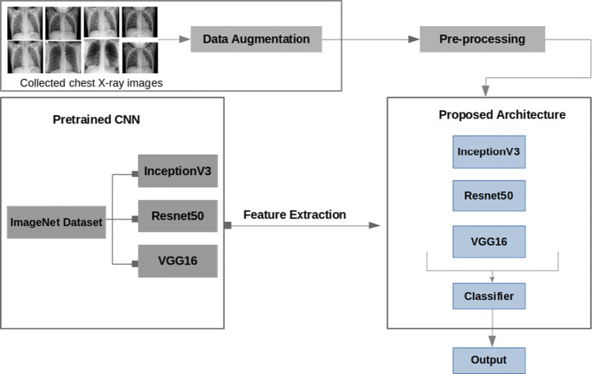

**Table-1 : Components & Technologies:**

| **S.No** | **Component** | **Description** | **Technology** |
| --- | --- | --- | --- |
| **1.** | **Data Collection** | **Sources of chest X-ray images (hospitals, online databases) - Web scraping tools (if collecting from online sources)** | **-.** |
| **2.** | **Data PreProcessing** | **Python libraries (NumPy, OpenCV) for image preprocessing - Data cleaning and formatting** | **Python** |
| **3.** | **Convolutional Neural Network** | **Deep learning framework (e.g., TensorFlow, PyTorch) - Model architecture (VGG16, ResNet, custom architecture)** | **Python Libraries and frameworks** |
| **4.** | **Training and Validation** | **Training data for the model - Validation data for model evaluation - Data augmentation techniques** | **Python Libraries and frameworks** |
| **5.** | **Hyperparameter Tuning** | **Hyperparameter optimization libraries (e.g., Keras Tuner)** | **Python Libraries and frameworks** |
| **6.** | **Model export** | **Tensorflow saved model format** | **Python Libraries and frameworks.** |
| **7.** | **Web Framework Flask** | **Flask for creating web application ,Python for backend development** | **Python FLask** |
| **8.** | **API design** | **Flask REST-ful API design** | **Flask RESTful** |
| **9.** | **User Interface** | **Frontend development of user interface** | **HTML,CSS,JS** |
| **10.** | **Version Control** | **To track changes and control** | **Version Control** |

**Table-2: Application Characteristics:**

| **S.No** | **Characteristics** | **Description** | **Technology** |
| --- | --- | --- | --- |
| **1.** | **Purpose** | **Automated detection of COVID-19 in chest X-ray images.** | **Deep learning frameworks (e.g., TensorFlow, PyTorch)** |
| **2.** | **Target** | **Users Healthcare professionals, researchers, and the general public.** | **HTML, CSS, JavaScript,** |
| **3.** | **Efficiency** | **The system should provide results quickly and efficiently.** | **.Backend optimizations, cloud-based computing (AWS, Google Cloud)** |

| **S.No** | **Characteristics** | **Description** | **Technology** |
| --- | --- | --- | --- |
| **4.** | **Accessibility** | **Should be accessible online via web or mobile interfaces.** | **Web and mobile application development** |
| **5.** | **User-Friendly** | **The interface should be easy to use and understand.** | **HTML CSS** |

**PROJECT PLANNING $ SCHEDULING**

**Project Planning Phase**

**Project Planning Template (Product Backlog, Sprint Planning, Stories, Story points)**

| **Sprint** | **Functional**  **Requirement (Epic)** | **User Story**  **Number** | **User Story / Task** | **Story Points** | **Priority** | **Team**  **Members** |
| --- | --- | --- | --- | --- | --- | --- |
| Sprint-1 | Establish the project's foundation | USN-1 | -Collect diverse chest X-ray datasets: Research and collect COVID-19 and normal chest X-ray datasets. Preprocess and clean the data: Organize and store data, resize, normalize, handle missing data. - Design a CNN architecture: Choose an appropriate architecture, split data into train, validation, and test sets, implement data augmentation.. | 10 | High |  |
| Sprint-2 | Develop and train the initial CNN model | USN-2 | - Train the CNN model: Configure model architecture, train on training set, implement early stopping and model checkpointing. - Evaluate model performance: Use validation set, implement evaluation metrics, identify areas for improvement. | 10 | High |  |
| Sprint-3 | Optimize the model's performance and prepare for deployment | USN-3 | - Fine-tune model hyperparameters: Perform hyperparameter tuning based on validation results, document the best hyperparameters. - Prepare for deployment: Export the trained model in a suitable format (e.g., TensorFlow SavedModel, ONNX), create a simple user interface for testing. | 10 | High |  |
| Sprint-4 | Finalize the project, conduct testing, and document | USN-4 | - Conduct testing and debugging: Test the model with COVID-19 and normal chest X-ray images, address and fix issues, ensure a functional user interface. - Document the project: Create project documentation, prepare a presentation or report for stakeholders. | 10 | High |  |
| Sprint-1 | Deploy the model  On flask. | USN-5 | - Set up Flask application: Establish a Flask application for deploying the model. - Model Integration: Integrate the trained model into the Flask application. - Create RESTful API: Develop a RESTful API endpoint for model inference. - Test Flask Deployment: Conduct testing and debugging for the Flask deployment. - Document Flask Deployment: Create documentation for the Flask deployment, including setup instructions and API documentation. | 10 | High |  |
|  |  |  |  |  |  |  |

| **Sprint** | **Total Story**  **Points** | **Duration** | **Sprint Start Date** | **Sprint End Date**  **(Planned)** | **Story Points**  **Completed (as on Planned End Date)** | **Sprint Release Date**  **(Actual)** |
| --- | --- | --- | --- | --- | --- | --- |
| Sprint-1 | 20 | 4 Days | 2 Nov 2023 | 5 Nov 2023 | 10 | 1 November 2023 |
| Sprint-2 | 20 | 4 Days | 6 Nov 2023 | 9 Nov 2023 | 10 | 1 November 2023 |
| Sprint-3 | 20 | 4 Days | 10 Nov 2023 | 13 Nov 2023 | 10 | 1 November 2023 |
| Sprint-4 | 20 | 4 Days | 14 Nov 2023 | 17 Nov 2023 | 10 | 1 November 2023 |

**CODING & SOLUTIONING**

**1)Libraries-**

**from imutils**

**import paths**

**import matplotlib.pyplot as plt**

**import numpy as np**

**import argparse**

**import cv2**

**import os**

**import time**

**import keras**

**2) Access to datasets-**

**We import the data set from Kaggle (https://www.kaggle.com/code/rollanmaratov/covid19-detection-using-tensorflow-from-chest-xray/data). From here we import the chest X rays of both covid and normal patients and import to the model.**

**3)Data Preprocessing**

**Convert the data and labels to Numpy arrays**

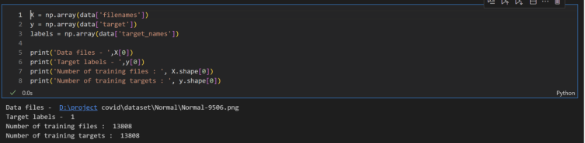

**Convert Images into arrays using keras-**

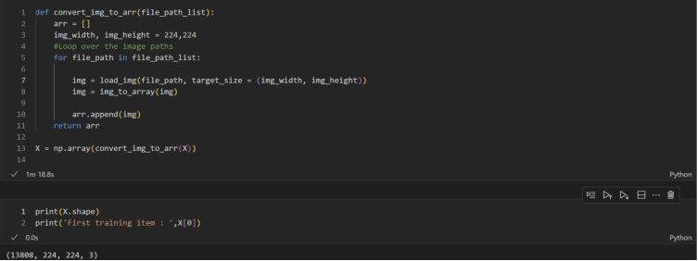

**Note that the shape of training data is (13808, 224, 224, 3)**

**- 13808 is the number of training items or files,**

**- (224,224) is the target size or image size provided while loading image**

**- 3 refers to the depth for colored images ( RGB channels ).**

**Rescaling it-**

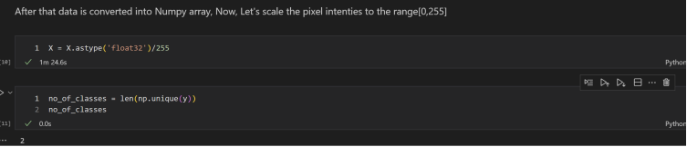

**The "rescale value" is a number that we will use to multiply the data before any other processing. The original images have RGB values between 0-255, but these values are too high for our models to process. Therefore, we aim to have values between 0 and 1 by scaling with a factor of 1/255. This ensures that all values in X will be within the 0-1 range.**

**So We created our Problem into a Binary Classification Problem,wheather it is infected or not-**

**0 or 1**

**Converts a class vector (integers) to binary class matrix by performing the one-hot encoding on the labels**

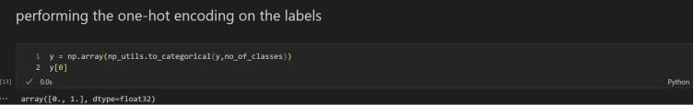

**Splitting the data into train, test and validation set**

**We also split the validation data set cause at the end of model building,we need a set of dataset just for accuracy and validation.**

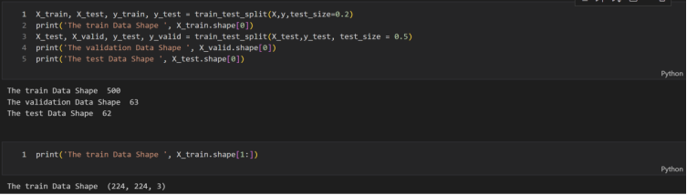

**4)CNN implementation with Resnet50**

**-Now we create a neural network model using the Sequential API in Keras. It starts with a pre-trained ResNet50 model as the first layer, followed by flatten, batch normalization, and fully connected layers.**

**-The last layer has the number of units equal to the number of classes in the problem, with a softmax activation function.**

**-The first layer's weights are frozen to preserve the pre-trained weights. This architecture allows for efficient feature extraction and classification.**

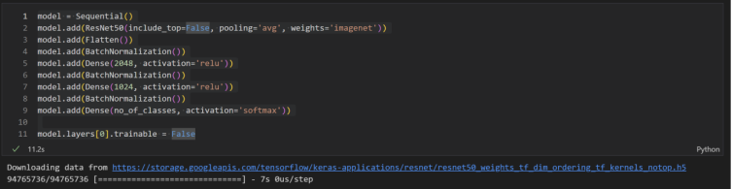

**5)Modelling**

**So For compiling the model we will use Adam Optimizer**

**for using the Adam optimizer with a specified learning rate to navigate through the parameter space during training. The learning rate is considered a crucial hyperparameter, and adjusting it can impact the convergence and stability of the optimization process, especially when dealing with potential challenges like getting stuck in local minima.**

**So we employ the Adam optimizer to guide the model toward the global minimum during training. If the training process encounters local minima, the Adam optimizer is expected to facilitate escaping from them and progressing towards the global minimum. Additionally, I'll define the learning rate for the optimizer, specifically setting it at 1e-3 (0.001).**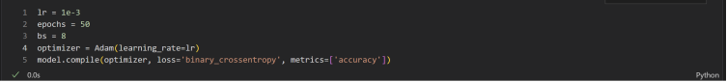

**Using model.fit_generator as I am using ImageDataGenerator to pass data to the model.**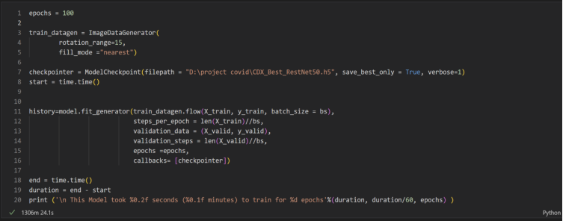

**6) Evaluation**

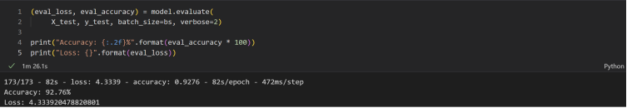

**7)Accuracy and loss graph**

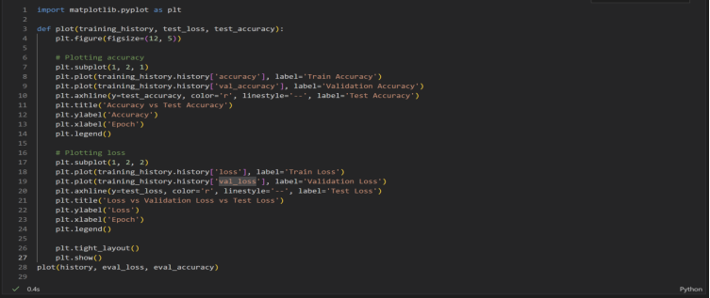

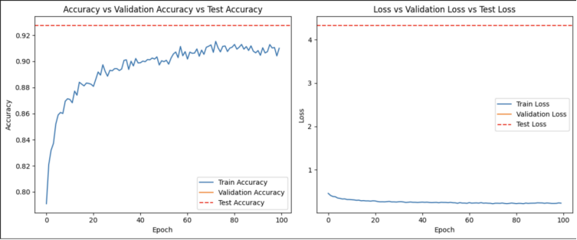

**8)Prediction**

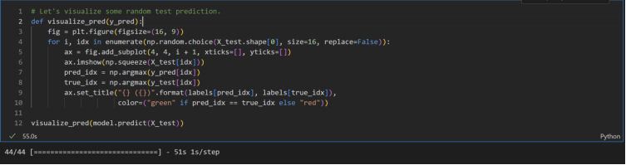

**a visualization function called visualize_pred has been implemented to showcase random test predictions. The function generates a 4x4 grid of subplots, each displaying an image from the test set. The titles of the subplots indicate the model's predictions and true labels. Correct predictions are labeled in green, while incorrect ones are labeled in red. This insightful visualization provides a quick and visual assessment of the model's performance on the test data. The function is applied to the predictions obtained from the model using model.predict(X_test)**

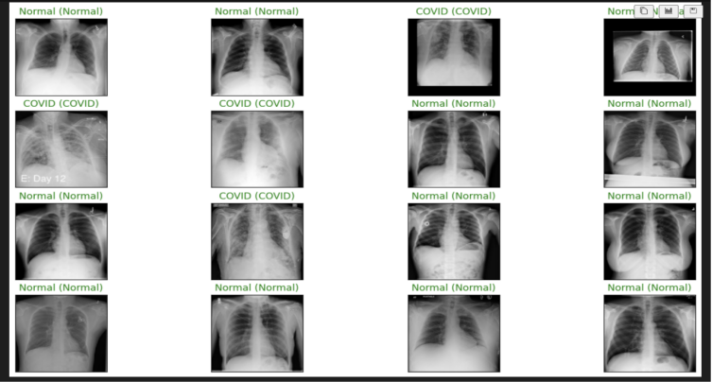

**PERFORMANCE TESTING**

**Confusion Matrix-**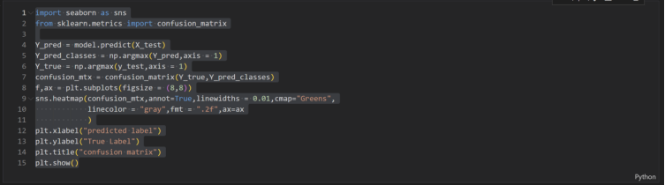

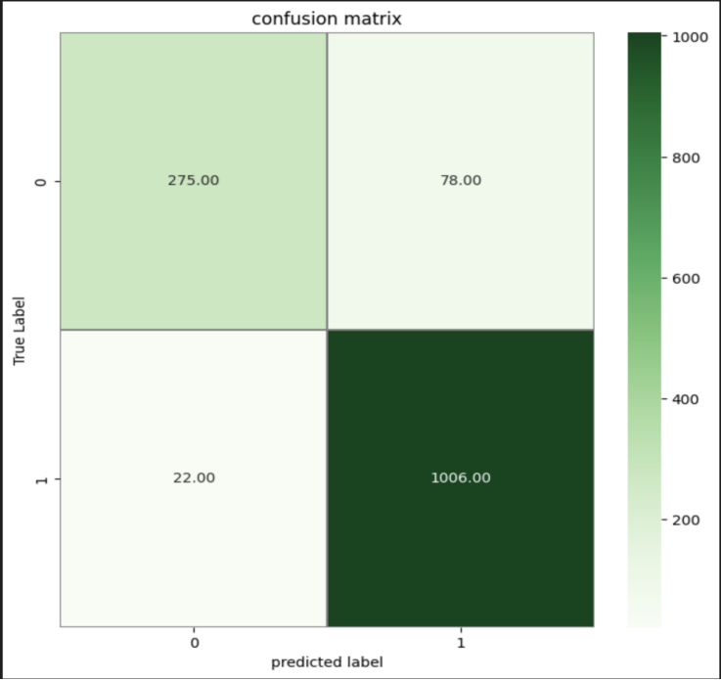

**Finally uploading the model**

**ADVANTAGES AND DISADVANTAGES**

**10.1 Advantages**

***10.1.1 Early Detection***

**One of the primary advantages of the project is its potential to enable early detection of Covid-19 cases. By leveraging deep learning on chest X-ray images, the system can identify patterns indicative of infection at an early stage, allowing for prompt medical intervention.**

***10.1.2 Automation and Efficiency***

**The automated nature of the deep learning model streamlines the diagnostic process, reducing the burden on healthcare professionals. This can lead to quicker turnaround times in diagnosis, especially during periods of high demand, such as a pandemic.**

***10.1.3 Resource Optimization***

**Efficient identification of Covid-19 cases through automated analysis of chest X-rays can contribute to resource optimization in healthcare settings. By assisting in prioritizing and allocating resources, the project may enhance the overall management of the pandemic.**

***10.1.4 Scalability***

**The deep learning model can be scaled for widespread use, potentially benefiting healthcare facilities with varying capacities. The scalability of the solution makes it adaptable to different healthcare settings and resource availability.**

**10.1.5 Continuous Learning and Improvement**

**The project can be designed to incorporate continuous learning mechanisms, allowing the model to improve over time with additional data. This adaptability enhances the model's accuracy and reliability as more information becomes available.**

**10.2 Disadvantages**

***10.2.1 Dataset Limitations***

**One significant challenge is the availability of diverse and well-annotated datasets. Limited datasets can impact the model's ability to generalize across different populations and conditions, potentially leading to biased or less accurate predictions.**

***10.2.2 Interpretability***

**The inherent complexity of deep learning models, especially convolutional neural networks, may result in a lack of interpretability. Healthcare professionals may find it challenging to understand the rationale behind the model's predictions, raising concerns about trust and acceptance.**

***10.2.3 Ethical Considerations***

**The deployment of AI in healthcare raises ethical concerns related to privacy, informed consent, and the responsible use of technology. Ensuring that the project adheres to ethical guidelines and regulations is crucial to its success and acceptance.**

***10.2.4 False Positives and Negative*s**

**No model is perfect, and there is a risk of false positives and false negatives. Misdiagnosing individuals can have serious consequences, and managing the trade-off between sensitivity and specificity is a critical consideration in the development of the deep learning model.**

***10.2.5 Resource Requirements***

**Implementing and maintaining a deep learning solution requires significant computational resources. Healthcare facilities with limited resources may face challenges in adopting and sustaining the technology, impacting its accessibility in certain settings.**

**FLASK DEPLOYMENT**

**CODE:**

**from flask import Flask, render_template, request**

**from tensorflow.keras.models import load_model**

**from tensorflow.keras.preprocessing import image**

**import numpy as np**

**from PIL import Image**

**import io**

**app = Flask(__name__)**

**model_path = "CDX_Best_RestNet50.h5"**

**model = load_model(model_path)**

**def preprocess_image(img):**

**img = img.convert("RGB") # Convert to RGB in case the image is not in RGB format**

**img = img.resize((224, 224)) # Resize image to match model's expected sizing**

**img_array = image.img_to_array(img)**

**img_array = np.expand_dims(img_array, axis=0)**

**return img_array**

**def predict(image):**

**try:**

**processed_img = preprocess_image(image)**

**predictions = model.predict(processed_img)**

**covid_probability = predictions[0][0]**

**if covid_probability > 0.5: # Adjust threshold as needed**

**return "COVID Positive"**

**else:**

**return "COVID Negative"**

**except Exception as e:**

**print(str(e))**

**return "Error occurred while processing the image"**

**@app.route("/", methods=["GET", "POST"])**

**def upload_file():**

**result = None**

**if request.method == "POST":**

**file = request.files["file"]**

**if file.filename == "":**

**return render_template("index.html", result="No selected file")**

**try:**

**img = Image.open(io.BytesIO(file.read()))**

**img.verify() # Verify if the file is an image**

**result = predict(img)**

**except Exception as e:**

**print(str(e))**

**return render_template(**

**"index.html", result="Invalid image file or unreadable image"**

**)**

**return render_template("index.html", result=result)**

**if __name__ == "__main__":**

**app.run(debug=True, port=8080)**

**Working:**

**The Flask code defines a web application with a single route ("/") handling both GET and POST requests. For GET requests, it renders an HTML template ("index.html") with no initial result displayed. Upon a POST request triggered by an uploaded file, the app verifies its validity, processes it as an image, and invokes a function to predict COVID-19 positivity. The predicted result ("COVID Positive" or "COVID Negative") is then displayed on the webpage. The app uses the Flask framework to create an interface for users to upload images for COVID-19 detection using a pre-trained ResNet50 model, offering a streamlined prediction experience through a web browser.**

**preprocess_image(img): This function takes an image as input, converts it to RGB format (if not already in that format), resizes it to match the model's expected input size (224x224 pixels), and preprocesses it for model inference by converting it into a numpy array.**

**predict(image): Accepts a preprocessed image as input and utilizes the pre-trained ResNet50 model to make a prediction regarding the probability of COVID-19 infection. It returns either "COVID Positive" if the model predicts a probability greater than 0.5 or "COVID Negative" otherwise.**

**upload_file() (route handler): This function handles both GET and POST requests to the root URL ("/"). Upon a POST request triggered by an uploaded file, it checks if a file has been selected. If a file is chosen, it attempts to read the uploaded image, verifies its validity, and calls the predict() function to obtain the COVID-19 prediction result based on the uploaded image. Any errors during this process are caught and an appropriate error message is displayed. The result is then rendered on the HTML template.**

**Index.html:**

**<!DOCTYPE html>**

**<html lang="en">**

**<head>**

**<meta charset="UTF-8" />**

**<title>PneumoScan19</title>**

**<style>**

**body {**

**font-family: Arial, sans-serif;**

**margin: 0;**

**padding: 0;**

**background-color: #f5f5f5; /* Light gray background */**

**display: flex;**

**flex-direction: column;**

**align-items: center;**

**height: 100vh;**

**}**

**header {**

**width: 100%;**

**background-color: #3498db; /* Light blue */**

**color: #ffffff; /* White text */**

**padding: 15px 0;**

**text-align: center;**

**box-shadow: 0px 2px 5px 0px rgba(0, 0, 0, 0.5); /* Subtle shadow */**

**}**

**nav {**

**width: 100%;**

**display: flex;**

**justify-content: flex-start; /* Align to the left */**

**background-color: #2980b9; /* Darker blue */**

**padding: 10px 20px; /* Padding adjusted */**

**}**

**nav a {**

**color: #ffffff; /* White text */**

**text-decoration: none;**

**font-weight: bold;**

**transition: background-color 0.3s ease;**

**border-radius: 4px;**

**padding: 10px 15px; /* Adjusted padding */**

**display: inline-block; /* Display links inline */**

**}**

**nav a:hover {**

**background-color: #1abc9c; /* Light green on hover */**

**}**

**.dropdown {**

**position: relative; /* Set dropdown as a relative position */**

**display: inline-block; /* Display dropdown inline */**

**}**

**.contributors {**

**display: none;**

**position: absolute; /* Position contributors dropdown absolutely */**

**left: 0; /* Shift dropdown to the left */**

**background-color: #ffffff;**

**box-shadow: 0px 0px 10px 0px rgba(0, 0, 0, 0.5);**

**border-radius: 4px;**

**z-index: 1; /* Ensure visibility over other elements */**

**}**

**.dropdown:hover .contributors {**

**display: block; /* Show contributors on hover */**

**}**

**.contributors a {**

**display: block;**

**margin-top: 5px;**

**text-decoration: none;**

**color: #333333; /* Dark gray text */**

**transition: color 0.3s ease;**

**font-weight: bold;**

**padding: 10px; /* Adjust padding */**

**}**

**.contributors a:hover {**

**color: #555555; /* Slightly lighter text on hover */**

**}**

**#upload-form {**

**background-color: #ffffff; /* White form background */**

**padding: 20px;**

**border-radius: 10px;**

**text-align: center;**

**box-shadow: 0px 0px 10px 0px rgba(0, 0, 0, 0.5);**

**margin-top: 20px;**

**}**

**h1 {**

**margin-top: 0;**

**color: #333333; /* Dark gray text */**

**}**

**input[type="file"] {**

**margin-bottom: 10px;**

**padding: 8px;**

**border: 1px solid #ccc;**

**border-radius: 4px;**

**}**

**input[type="submit"] {**

**background-color: #3498db; /* Blue button */**

**color: #ffffff; /* White text */**

**padding: 12px 20px;**

**border: none;**

**border-radius: 4px;**

**cursor: pointer;**

**transition: background-color 0.3s ease;**

**}**

**input[type="submit"]:hover {**

**background-color: #2980b9; /* Darker blue on hover */**

**}**

**.result {**

**margin-top: 20px;**

**font-size: 18px;**

**}**

**.result.positive {**

**color: #e74c3c; /* Red for positive result */**

**}**

**.result.negative {**

**color: #2ecc71; /* Green for negative result */**

**}**

**</style>**

**</head>**

**<body>**

**<header>**

**<h1>COVID-19 Detection using X-ray</h1>**

**<nav>**

**<div class="dropdown">**

**<a href="#" class="dropbtn">Contributors</a>**

**<div class="contributors" id="contributors">**

**<a**

**href="https://www.linkedin.com/in/vatsal-shah-528412218/"**

**target="_blank"**

**>Vatsal</a>**

**<a href="https://www.linkedin.com/" target="_blank">Rohit</a>**

**<a href="https://www.linkedin.com/" target="_blank">Harsh</a>**

**<a href="https://www.linkedin.com/" target="_blank">Tej</a>**

**<!-- Add more contributors with LinkedIn profile links -->**

**</div>**

**</div>**

**</nav>**

**</header>**

**<div id="upload-form">**

**<h1>Upload Chest X-ray Image</h1>**

**<form action="/" method="post" enctype="multipart/form-data">**

**<input type="file" name="file" />**

**<br />**

**<input type="submit" value="Upload" />**

**</form>**

**{% if result %}**

**<div**

**class="result {% if result == 'COVID Positive' %}positive{% elif result == 'COVID Negative' %}negative{% endif %}"**

**>**

**<h2>Result: {{ result }}</h2>**

**</div>**

**{% endif %}**

**</div>**

**<script>**

**document**

**.querySelectorAll(".dropbtn")[0] .addEventListener("click", function () {**

**var dropdownContent = document.getElementById("contributors");**

**if (dropdownContent.style.display === "block") {**

**dropdownContent.style.display = "none";**

**} else {**

**dropdownContent.style.display = "block";**

**}**

**});**

**</script>**

**</body>**

**</html>**

**OUTPUT:**

**Website UI:**

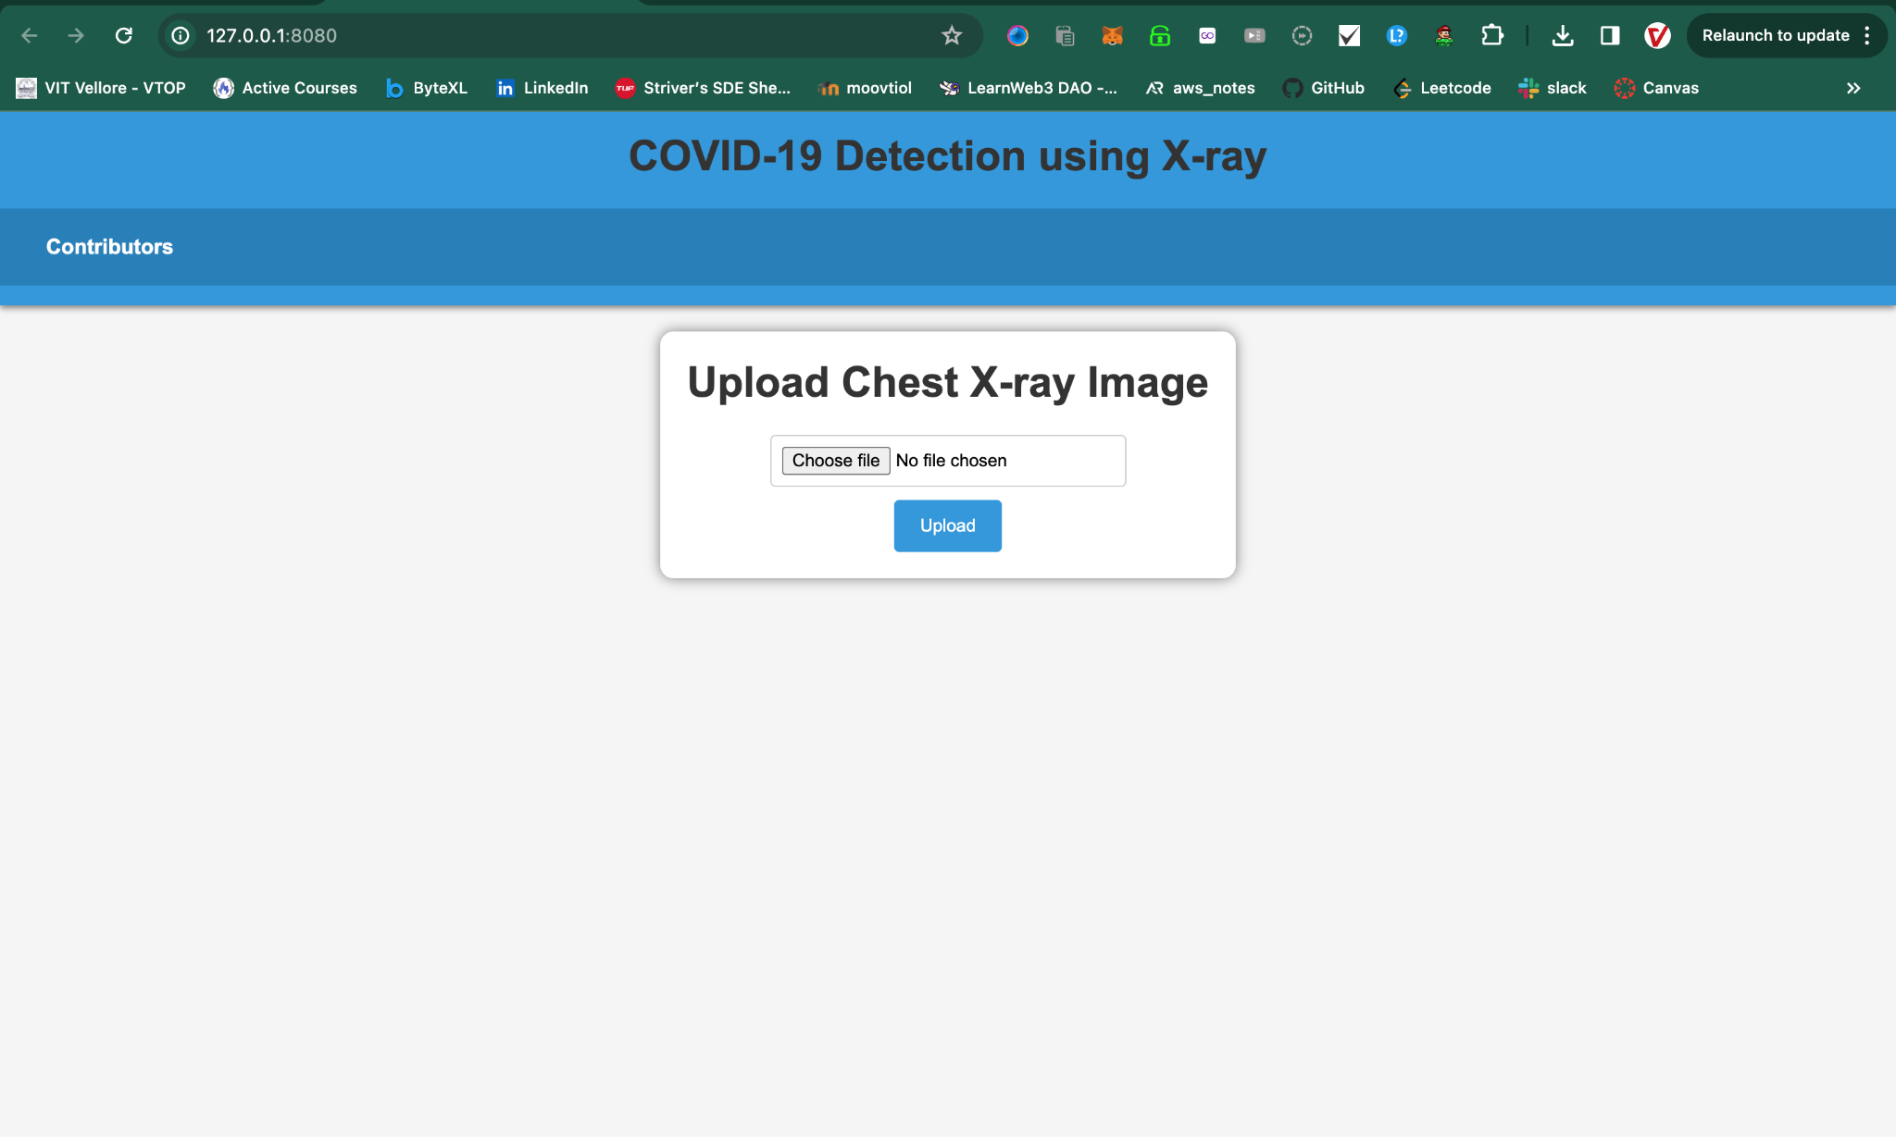

**Taking Chest-Xray as input:**

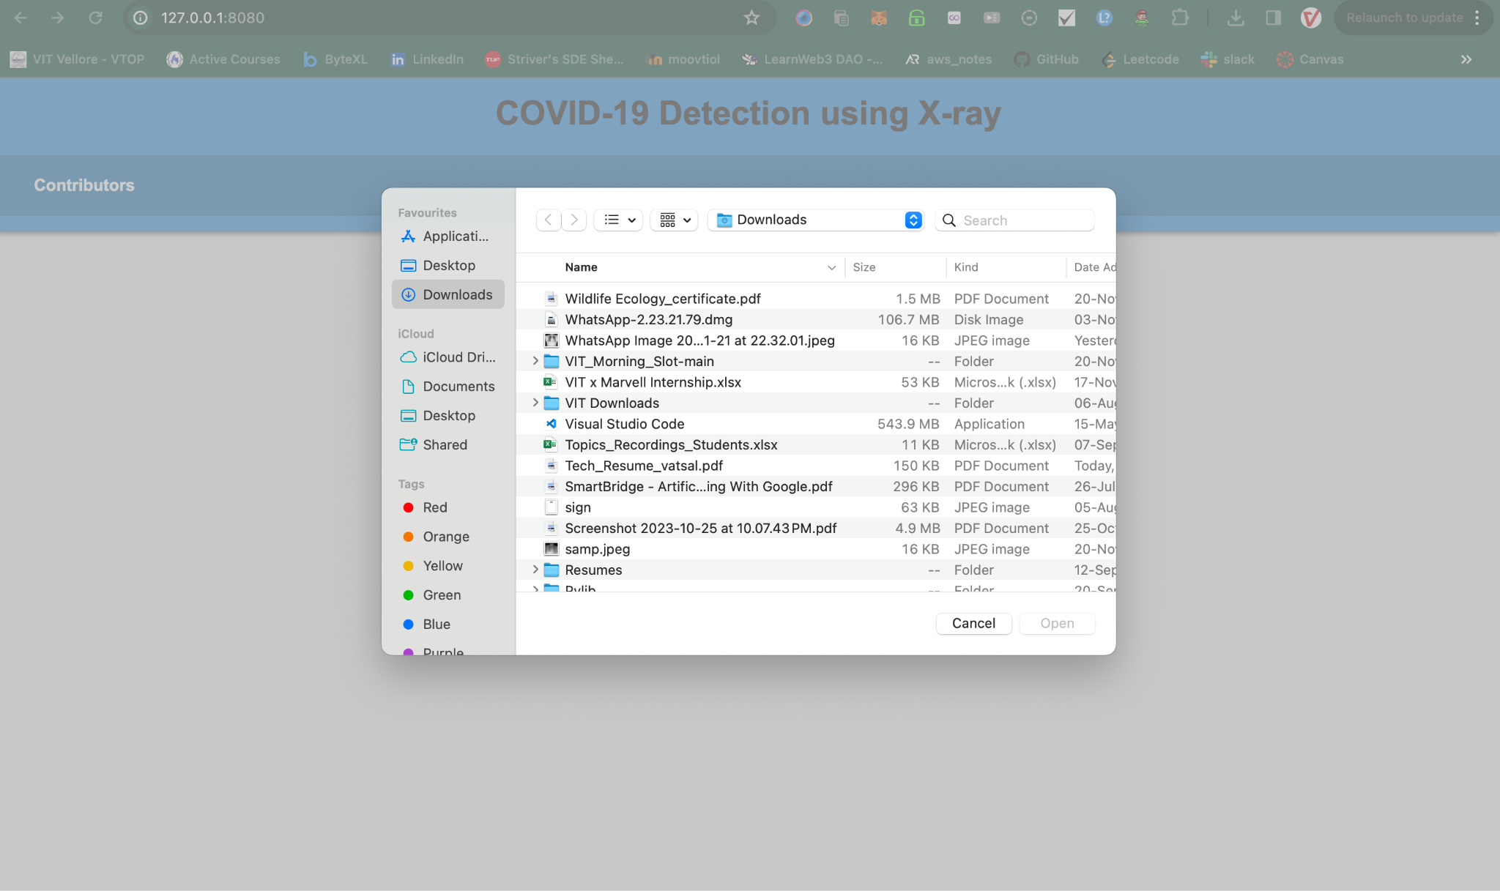

**Displaying the Output:**

**1)Samp.jpeg**

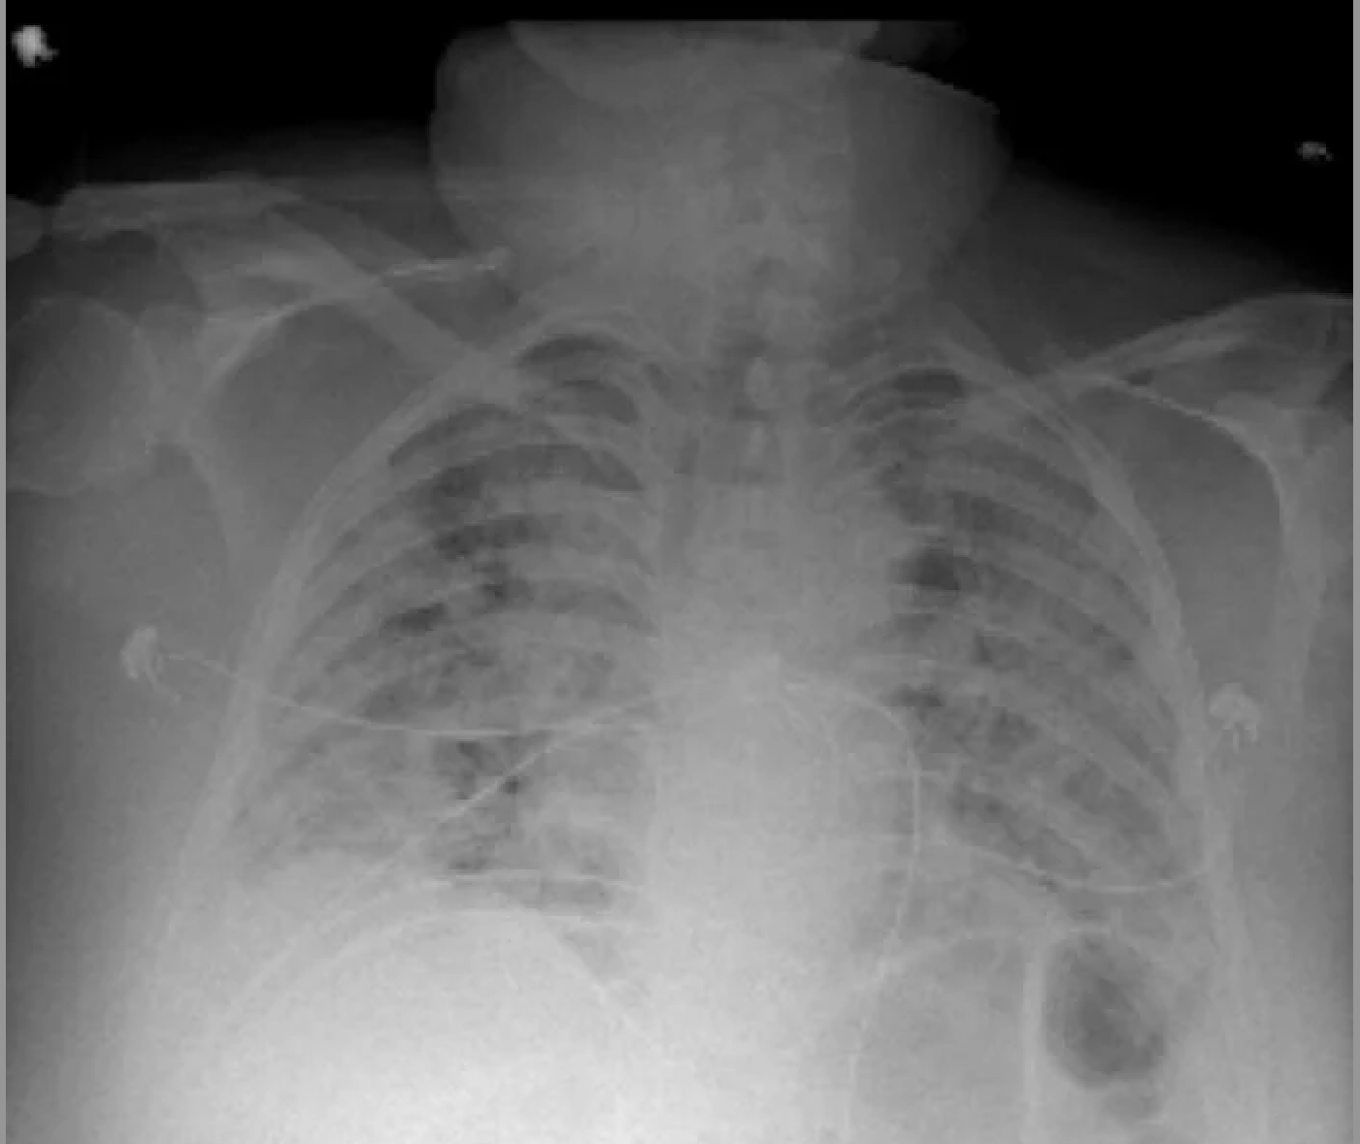

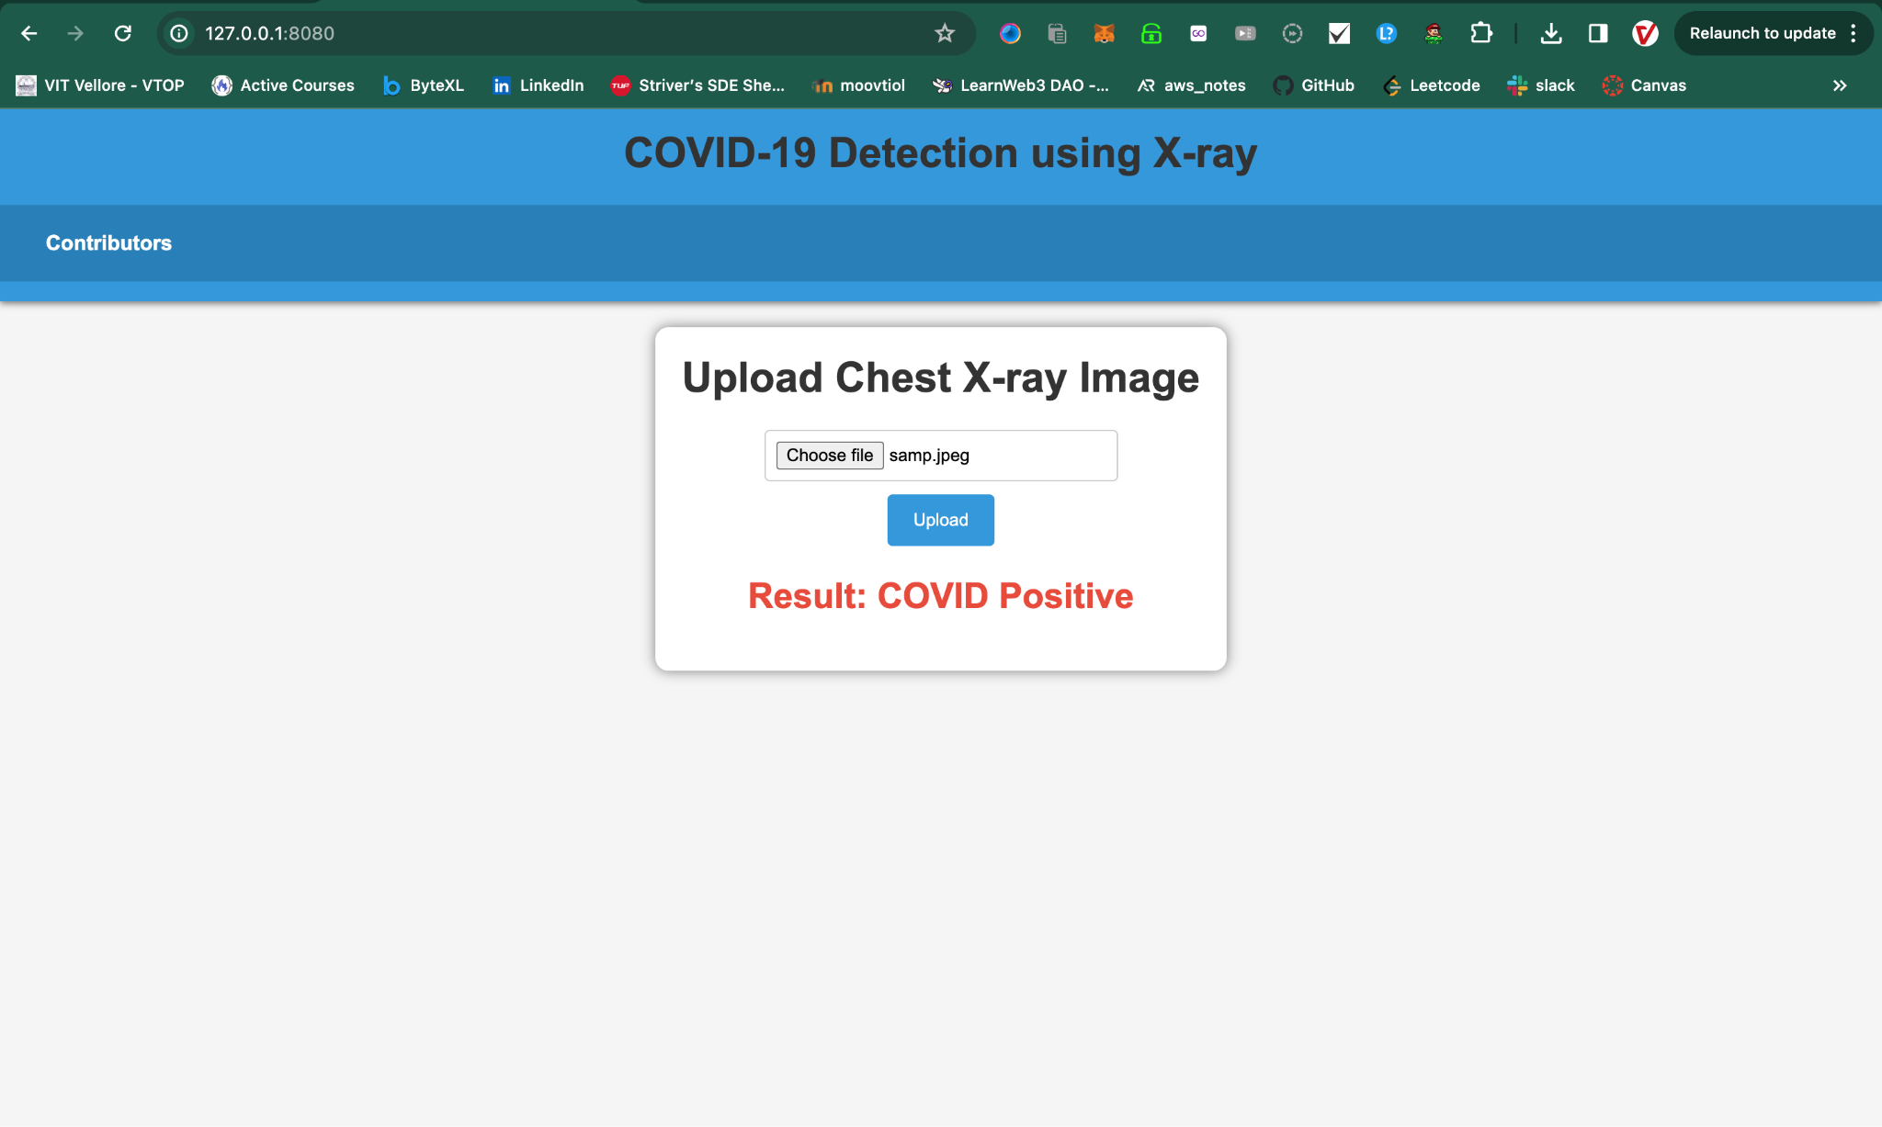

**2) 1.webp:**

